Avoiding the Indwelling Urinary Catheter

Alternatives to an indwelling urinary catheter should be considered based on a patient’s individual care needs. Why? In general, alternative devices and procedures provide a much lower risk of infectious complications, such as urinary tract infection. Additionally, these alternative methods can reduce or eliminate the non-infectious complications – such as discomfort and immobility – that are associated with indwelling urethral (also called “Foley”) catheters.

The most common alternatives to the indwelling catheter are:

- External catheter for men (also called a “condom catheter,” which is a urine containment device fitted over the genitalia and is attached to a urinary drainage bag);
- Intermittent (“in-and-out” or “straight”) catheterization;
- Programmed toileting (behavioral therapy); and
- Suprapubic catheter (surgically inserted into the bladder through an incision above the pubis).

The following pages provide further information on these alternatives.

We discuss below the most common alternatives to the indwelling urinary catheter:

- External catheters for men (condom catheters),
- Intermittent (“in-and-out” or “straight”) catheterization,
- Programmed toileting, and
- Suprapubic catheterization.

External catheters for male patients are underused. A national survey of hospitals found that external catheters were almost always or always used in only 14% of hospitals, however, there was a statistically higher use in VA hospitals.1 This low level of use persists despite evidence that condom catheters lower the risk of infectious and other complications of urinary catheterization and are more acceptable to patients.2 When using condom catheters, it is important to choose an appropriate size to improve fit and adherence despite patients’ movement.

Condom catheter
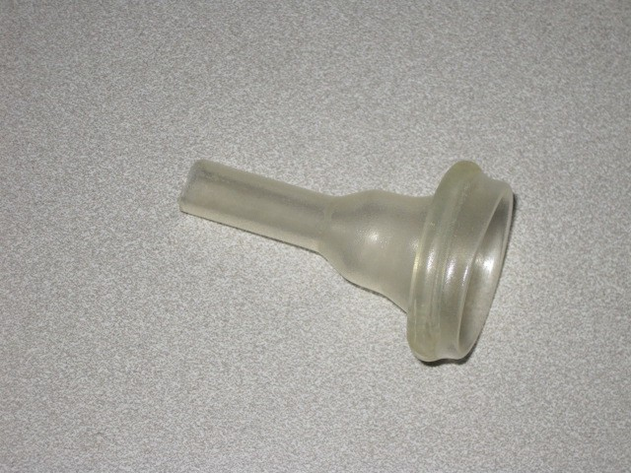
Intermittent catheterization, often used in patients with neurogenic bladder or spinal cord injury, lessens the risk of urinary tract infection. Intermittent catheterization is preferable to indwelling urethral or suprapubic catheters in patients with bladder emptying dysfunction. When the patient returns to the community, intermittent catheterization enhances patient privacy and dignity, and facilitates return to activities of daily living.3 it is important to perform intermittent catheterization at regular intervals to avoid over- distending the bladder. Among hospitalized patients, intermittent

catheterization is often used in combination with a portable bladder ultrasound. Portable bladder ultrasound is a non-invasive portable tool for diagnosing and managing urinary outflow dysfunction. For example, portable bladder ultrasound could be used to detect that a patient has insufficient quantities of urine to justify catheterization.
Toileting programs typically consist of a patient-specific assessment of incontinence followed by a program of prompted voiding, habit retraining, and/or timed voiding as part of an individualized care plan. Evidence from one investigation demonstrates toileting programs can significantly lessen risk of falls, skin breakdown – and, if patient lifting technology is available, back injuries experienced by personnel during patient assists.4,5 Emphasis on self-voiding also results in less post void residual compared to use of indwelling urinary catheters.5
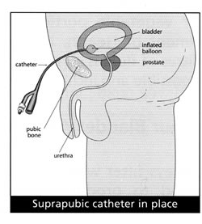
Suprapubic catheter [Image from the Duke of Cornwall Spinal Treatment Center, accessed December 27, 2010 from http://www.spinalinjurycentre.org.uk/information/029.asp?UType=1&CType=1]
Note: Website no longer available, but an archived version is available here, though some information may be out of date.

Suprapubic catheterization is an alternative to the Foley catheter. It can be used for both short- and long-term catheterization. However, in general, intermittent urethral catheterization is preferable to suprapubic catheterization. Insertion of the suprapubic catheter should be performed by a health professional with training and expertise in this procedure.
Guidelines on insertion and care of this device have been published.6

References

- Saint S, Kowalski CP, Kaufman SR, et al. Preventing hospital‐acquired urinary tract infection in the United States: a national study. Clin Infect Dis. 2008;46:243‐50.
- Saint S, Kaufman SR, Rogers MA, Baker PD, Ossenkop K, Lipsky BA. Condom versus indwelling urinary catheters: a randomized trial. J Am Geriatr Soc. 2006;54:1055‐61.
- Gould CV, Umscheid CA, Agarwal RK, Kuntz G, Pegues DA. Guideline for prevention of catheter‐ associated urinary tract infections 2009. Infect Control Hosp Epidemiol. 2010;31:319‐26.
- Morgan C, Endozoa N, Paradiso C, McNamara M, McGuire M. Enhanced toileting program decreases incontinence in long term care. Jt Comm J Qual Patient Saf. 2008;34:206‐8.
- Fink HA, Taylor BC, Tacklind JW, Rutks IR, Wilt TJ. Treatment interventions in nursing home residents with urinary incontinence: a systematic review of randomized trials. Mayo Clin Proc. 2008;83:1332‐43.
- Harrison SC, Lawrence WT, Morley R, Pearce I, Taylor J. British Association of Urological Surgeons' suprapubic catheter practice guidelines. BJU Int . 2010; Nov 4. doi:10.1111/j.1464- 410X.2010.09762.x.

